Locust je potpuno besplatan i open-source.

Download Locust

Službena stranica
Locust Official Website

GitHub
Locust GitHub

Dokumentacija
Locust Documentation

Instalacija

Python pip
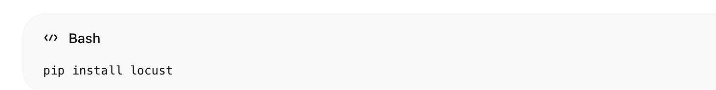
pip install locust

Provjera
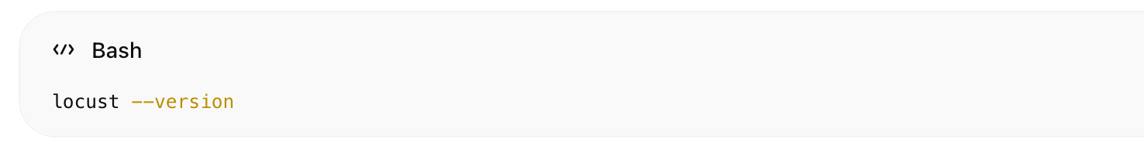
locust --version

Pokretanje
Ako imaš:
locustfile.py

pokretanje:
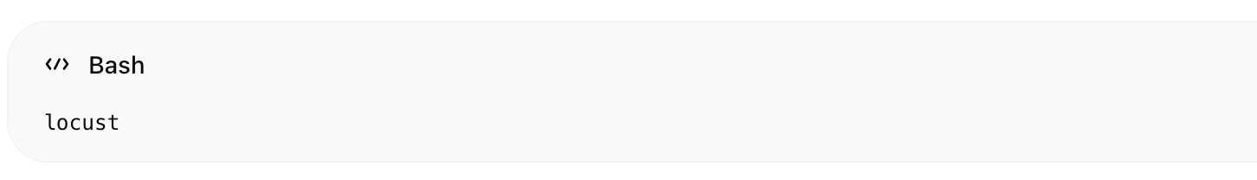
locust

Web UI
http://localhost:8089

Za tvoj Smart Grid projekt
Locust koristimo kao:

IoT simulator
- 1000 trafostanica
- MQTT telemetry generator
- anomaly simulation
- overload simulation
- blackout simulation

Preporučeni Python paketi
Uz Locust dodaj:
pip install paho-mqtt faker numpy

Zašto Locust za ovaj projekt
✔ lagan
✔ Python-based
✔ lako generira IoT telemetry
✔ distributed load testing
✔ realtime scaling

Tvoj stack sada
Layer | Technology
IoT Simulation | Locust
MQTT Broker | EMQX
Analytics DB | CrateDB
Backend/API | FastAPI
Frontend SCADA | Vue.js + Quasar Framework
AI Layer | scikit-learn + PyTorch Geometric
窗体顶端

窗体底端

